- WE WILL SPEAK OUT AGAINST ANY DISCRIMINATION TOWARDS WOMEN
- NOUS NOUS ELEVERONS CONTRE TOUTE DISCRIMINATION ENVERS LES FEMMES
1ERE ST2S A. LYCEE POLYVALENT BERTENE JUMINER. SAINT LAURENT DU MARONI
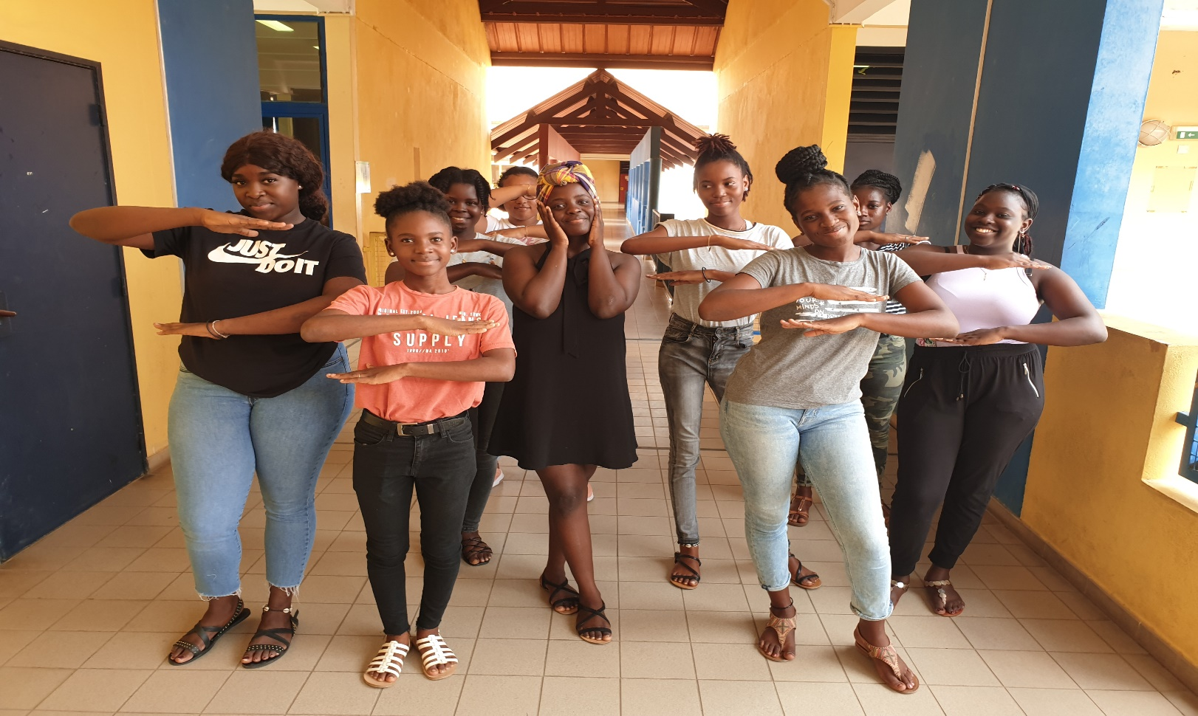

#EachforEqual

